Task 2 Heuristics

Heuristics are mental shortcuts that can facilitate problem-solving and probability judgments. These strategies are generalizations, or rules-of-thumb, reduce cognitive load, and can be effective for making immediate judgments, however, they often result in irrational or inaccurate conclusions.

The approach and heuristics that we will be using on this project is based on the SIFT methodology that is bases on 4 steps:

* Stop
* Investigate the Source
* Find better coverage
* Trace claims, quotes, and media to the original context.

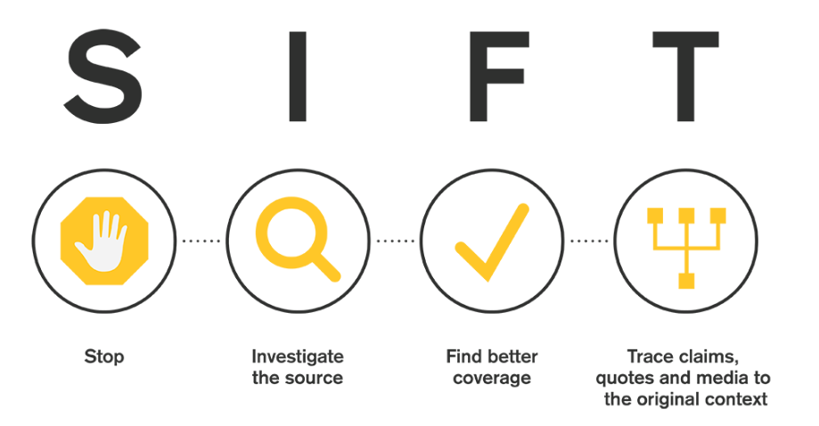

Reference:

(Caulfield, 2022), [What is the SIFT Method? - Information Evaluation - Los Angeles Valley College Library at Los Angeles Valley College (lavc.edu)](https://lib.lavc.edu/information-evaluation/siftmethod)